Distortion of the CV characteristics by a high current
Technical Note by A.Chilingarov, Lancaster University, UK

- Introduction
CV measurements with the strip detectors are usually performed between the sensor backside and the bias rail in C_{s}-R_{s} mode. C_{s} represents the capacitance between all strips and the backside in the depleted volume while the R_{s} represents all bias resistors, R_{bias}, connected in parallel plus the resistance of the un-depleted bulk. It was observed experimentally that the results may be distorted by a high sensor current. The aim of this Note is to understand possible reasons for this distortion.

- Generation current model
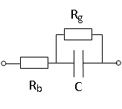
High current may be interpreted as the presence of an additional resistor with a relatively low value in the circuit diagram. If the current is mostly generated inside the depleted volume then an additional resistor, R_{g}, appears in parallel to the capacitance of the depleted part of the sensor, C, as shown in the diagram presented in Fig.1.

Fig. 1. Circuit diagram for the generation current model
Here R_{b} denotes an effective resistance consisting of the bias resistors connected in parallel plus the resistance of the un-depleted bulk. As shown in the appendix the C_{s} and R_{s} values for the above circuit measured at frequency f are the following:

$C_{s}=C\frac{1+Q_{p}^{2}}{Q_{p}^{2}}$ , (1)
$R_{s}=R_{b}+\frac{R_{g}}{1+Q_{p}^{2}}$ . (2)
Here Q_{p} = ωCR_{g} and ω=2πf. Obviously C_{s} > C and R_{s} > R_{b}. If R_{g}→∞ then Q_{p}→∞, C_{s}→C and R_{s}→R_{b}. If R_{g}→0 then Q_{p}→0, C_{s}→∞ and R_{s}→R_{b}. The maximum value of R_{s} equal to R_{b}+R_{g}/2 is achieved when Q_{p}=1.
- Leakage current model
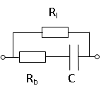
If the current is mostly due to leakage over the sensor edge then an additional resistor, R_{l}, appears in parallel to C and R_{b} connected in series as shown in the diagram presented in Fig.2.

Fig. 2. Circuit diagram for the leakage current model
As shown in the appendix the C_{s} and R_{s} values for the above circuit measured at frequency f are the following:
$C_{s}=C\frac{1+D_{s}^{2}}{ρ^{2}D_{s}^{2}}$ , (3)
$R_{s}=ρ(R_{b}+\frac{R_{l}}{1+D_{s}^{2}}$) . (4)
Here ρ=R_{l}/(R_{l}+R_{b}) and D_{s}=ωC(R_{l}+R_{b}). Obviously ρ < 1 and C_{s} > C. If R_{l}→∞ then ρ → 1, D_{s}→∞, C_{s}→C and R_{s}→R_{b}. If R_{l}→0 then ρ → 0, D_{s}→ ωCR_{b}, C_{s}→∞ and R_{s}→0.

- Application to the experimental data
The above models were used to interpret the experimental data obtained with un-irradiated sensor w01-bz4-p4 produced within the ATLAS upgrade program. The sensor has 104 strips with the total area of ~0.8x0.8 cm² and a thickness of ~300 μm. The bias resistors have a value of ~2 MΩ. Connected in parallel they give the resistance, R_{b}, of ~2000 kΩ/100=20 kΩ. The CV measurements were made at a frequency of 10 kHz. Fig.3 shows the current, C_{s} and R_{s} values vs bias voltage.
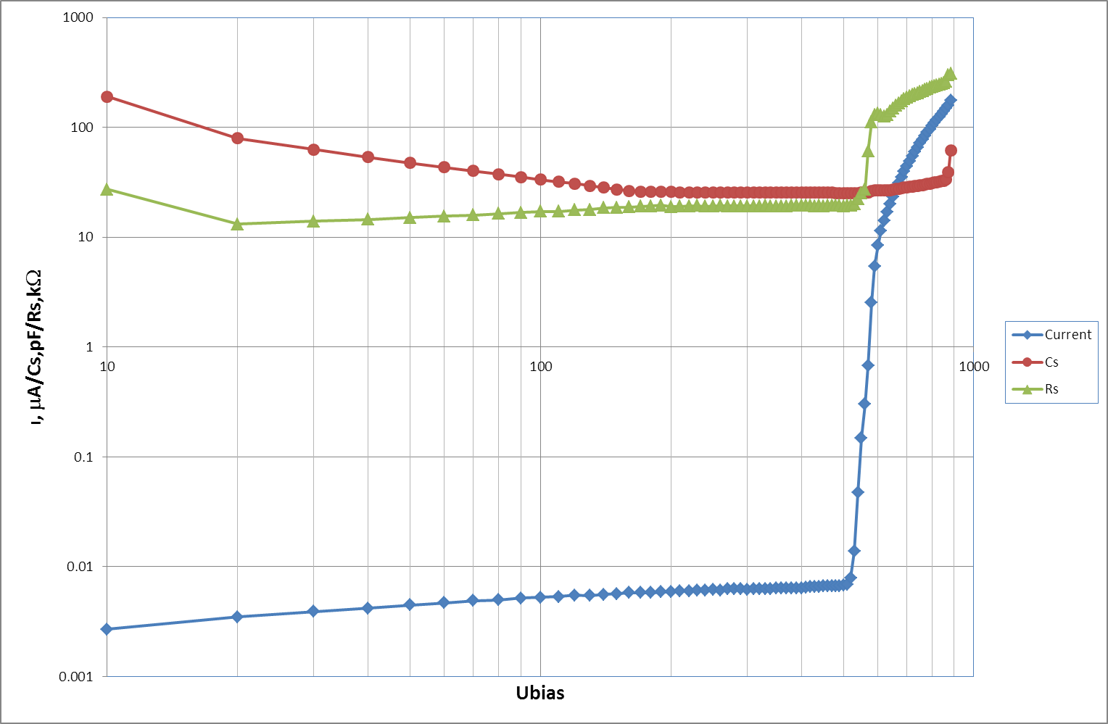

Fig.3. The current, C_{s} and R_{s} vs bias voltage for the strip mini-sensor w01-bz4-p4.
Above 200V the sensor is fully depleted with C_{s} and R_{s} reaching a plateau. Above 500V the current grows steeply and both C_{s} and R_{s} increase with bias.
It was assumed that the additional resistance (R_{g} or R_{l} in Figs 1 and 2) can be estimated from the IV curve as the dynamic resistance: R_{dyn} = dU/dI. It is shown in Fig.4 vs bias. At low U_{bias} it has a very high value of ~10⁵ MΩ but above 500 V it drops, first sharply and then more slowly, to a few MΩ level. Note however that even the lowest R_{dyn} is still much higher than the R_{s} plateau value of ~ 20 kΩ.

Verification of the models was made as follows. The average C_{s} and R_{s} values between 200V and 260V were assumed to represent C and R_{b} in the diagrams shown in Figs 1 and 2. The R_{g} for the first model and R_{l} for the second one were set to the R_{dyn} value. Then, using Equations (1) – (4), C_{s} and R_{s} were calculated above 200 V and compared with the experimental data. The results are presented in Figs 5 and 6.
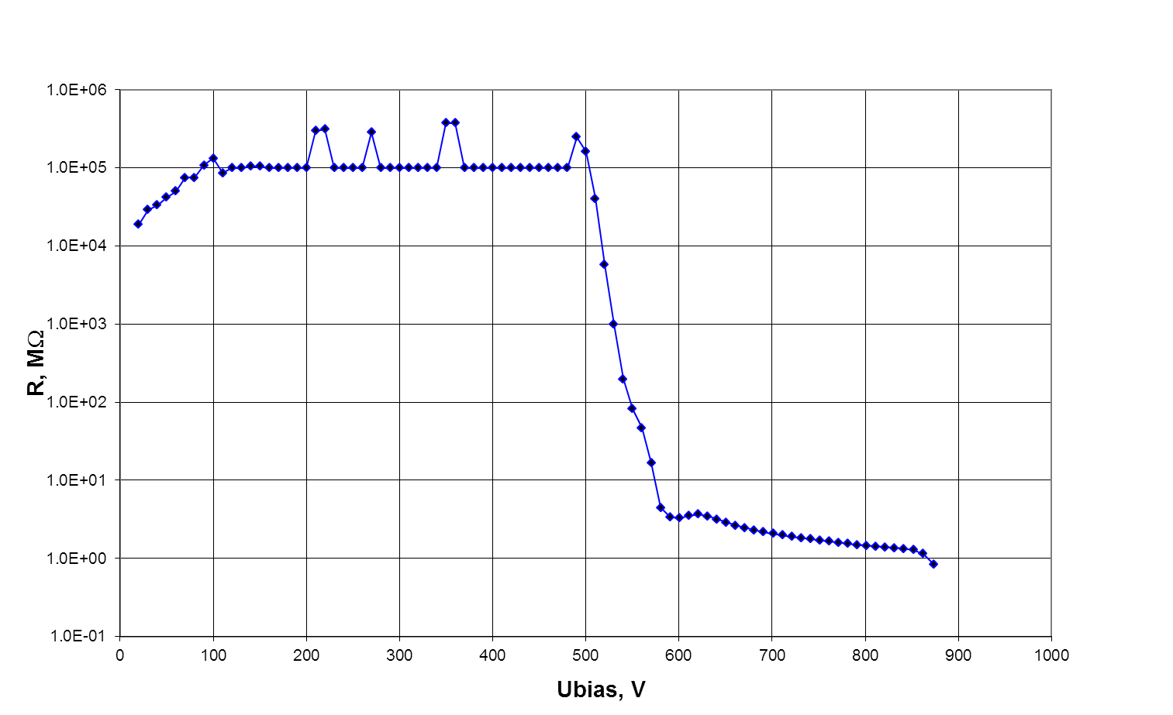

Fig.4. The dynamic resistance dU/dI extracted from the IV curve
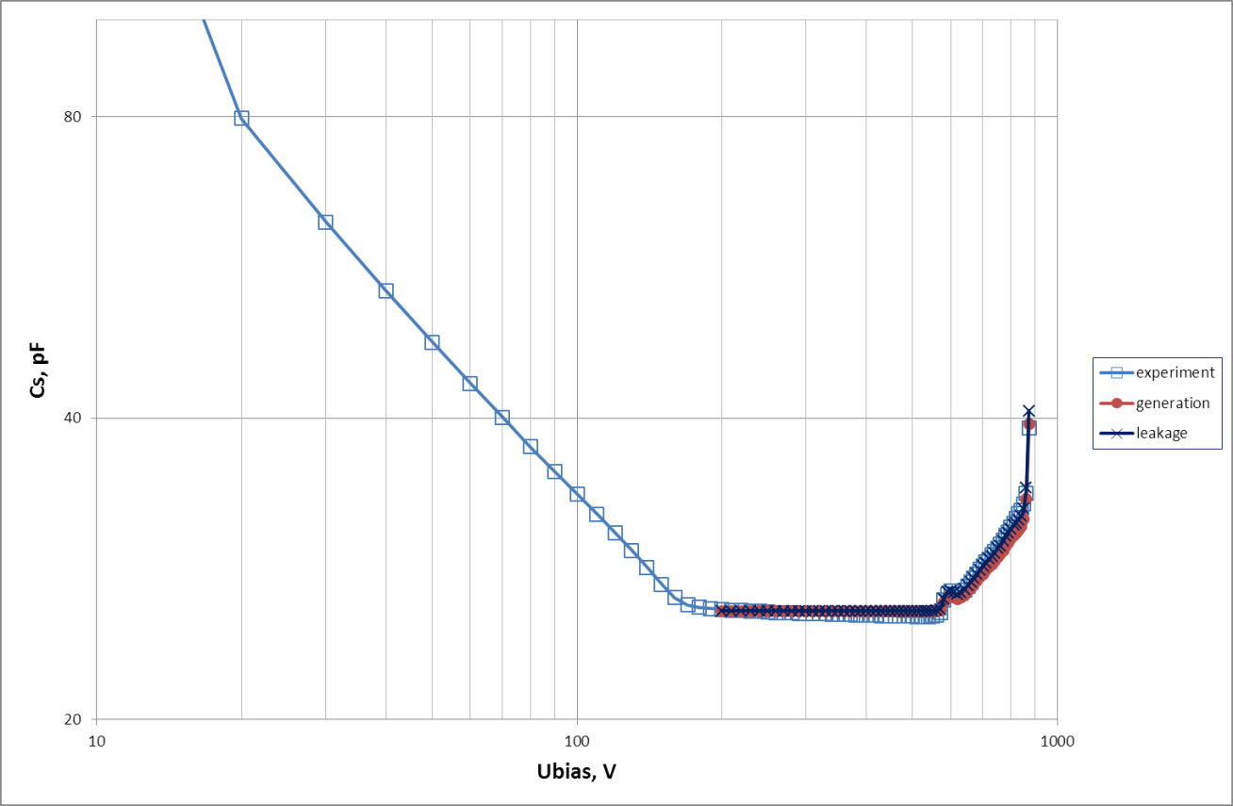

Fig.5. C_{s}: measured experimentally and calculated from the two models.
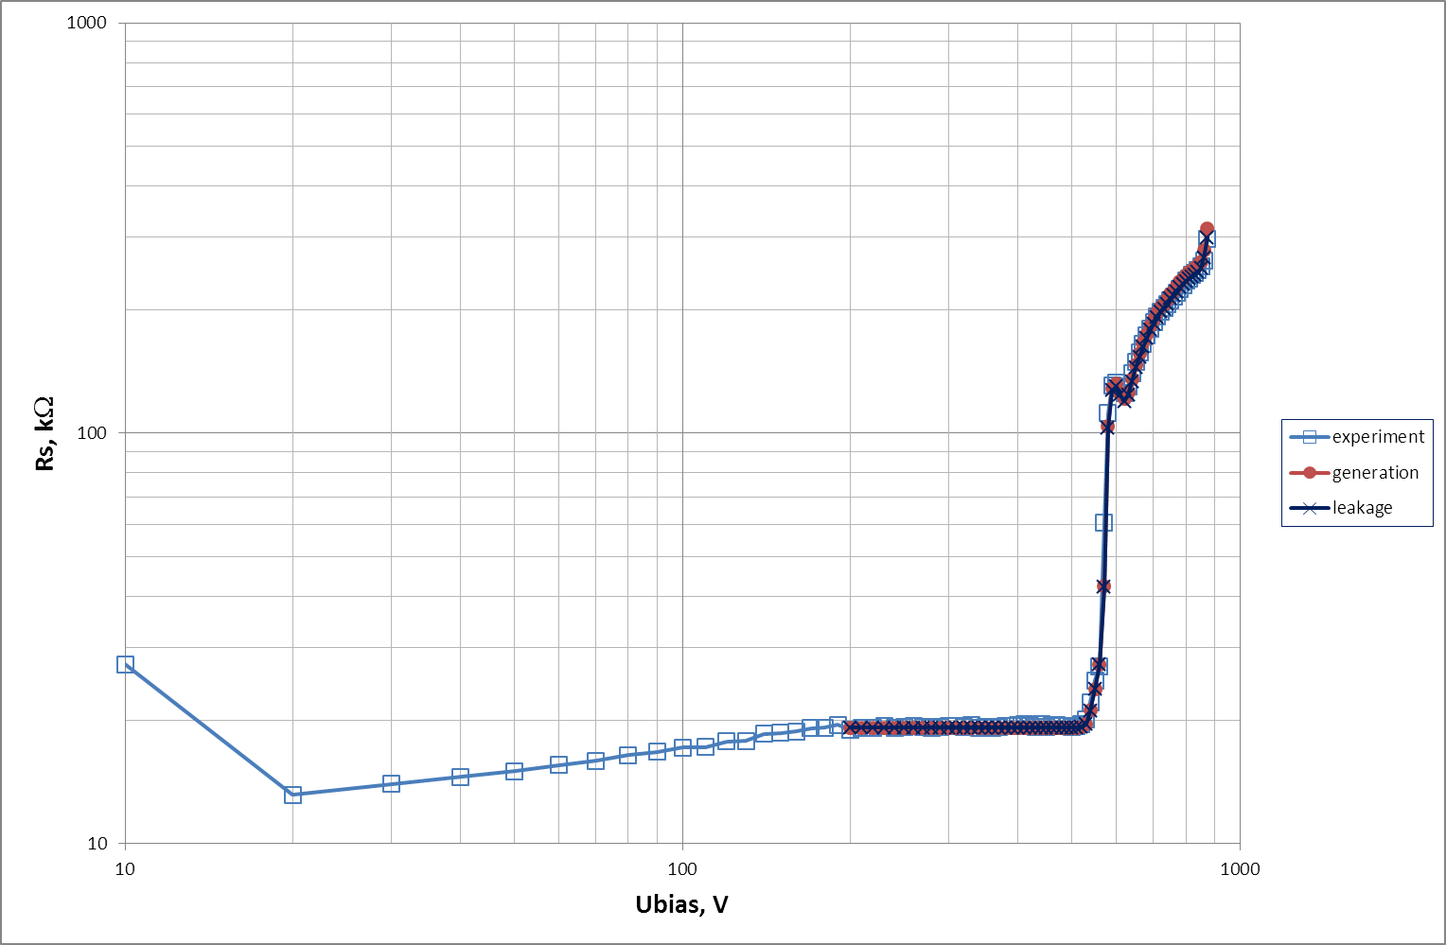

Fig.6. R_{s}: measured experimentally and calculated from the two models.

- Discussion
As seen in Figs 5 and 6 both models reproduce the experimental data reasonably well. It is not surprising that both models give very similar results. As mentioned above, the R_{b} of ~20 kΩ is much smaller than R_{dyn} > 1 MΩ. In this case it is not important whether R_{dyn} is connected in parallel to the whole C - R_{b} chain as in Fig. 2 or to the capacitance alone as in Fig.1. Mathematically it can be explained as follows. The value of ρ in Equations (3) and (4) is always very close to 1 and the value of D_{s} is close to ωCR_{l}. In this situation Equations (3) and (4) revert to Equations (1) and (2) with R_{l} in place of R_{g}.

In the above example the additional resistor value set to dU/dI explains the experimental data quite well. However this is not always the case. Moreover the high current may have both generation and leakage components and the equivalent circuit diagram should be a combination of those presented in Figs 1 and 2 and include both R_{g} and R_{l}. The C_{s} and R_{b} values in this case can be found combining Equations (1) – (4). It was mentioned already that for both models C_{s} is larger than the actual capacitance C. It is easy to demonstrate that the same is true for the circuit including both R_{g} and R_{l}.

First, the part of the circuit containing R_{g} (shown in Fig.1) can be converted into an equivalent C_{s} - R_{s} chain using Equations (1) and (2). Let us denote the resulting parameters as C_{sg} and R_{bg}. Then it can be complemented by R_{l} connected in parallel. The final C_{s} and R_{s} values can be found from Equations (3) and (4) using C_{sg} in place of C and R_{bg} in place of R_{b}. Clearly: C_{s} > C_{sg} > C. Thus whatever additional resistor (or both of them) should be included in the equivalent diagram the resulting C_{s} is always larger then C.

- Conclusions
The distortion of the experimentally measured C_{s} and R_{s} parameters can be explained as resulting from an additional resistance with a relatively low value, which appears because of a high current. The equivalent circuit diagram can be the one shown in Fig.1 or Fig.2 or a combination of both. In the example presented in this Note the value of the additional resistance was assumed to be equal to the dynamic resistance following from the IV characteristic, R_{dyn} = dU/dI. This allowed calculation of the C_{s} and R_{s} values above their plateau for two simple models. Both of them gave very similar results, which agreed well with the experimental data. In the general case finding the additional resistor value is not so straightforward. Moreover the actual equivalent circuit may include both R_{g} and R_{l}. In all cases however the resulting C_{s} value is higher than the actual capacitance C. Thus a high leakage current should always lead to an increase in the measured capacitance.

Appendix
To find the values of C_{s} and R_{s} for any circuit one has to calculate its complex impedance Z and compare it with
$Z=R_{s}-\frac{j}{ωC_{s}}$ (A1)
- Generation current model
The impedance of the circuit shown in Fig.1 is the sum of R_{b} and the impedance, Z_{p}, of C in parallel to R_{g}. The conductance of this circuit G_{p}=1/Z_{p} can be written as
$G_{p}=\frac{1}{R_{g}}+jωC=\frac{1+jQ_{p}}{R_{g}}=\frac{1+Q_{p}^{2}}{R_{g}\left(1-jQ_{p}\right)}=\frac{1}{Z_{p}}$ . (A1.1)
Here Q_{p} = ωCR_{g} is the quality factor of the C-R_{g} circuit, ω=2πf, where f is the measurement frequency. Thus the whole impedance can be written as
$Z=R_{b}+\frac{R_{g}}{1+Q_{p}^{2}}-\frac{{jQ}_{p}^{2}}{ωC\left(1+Q_{p}^{2}\right)}$ . (A1.2)
Comparing Equations (A1.2) and (A1) one obtains Equations (1) and (2). Note that C_{s} does not depend on R_{b} but only on R_{g}. C_{s} is close to C if Q_{p}² >> 1. To what extent R_{s} is simultaneously close to R_{b} depends on the relation between the R_{g} and R_{b} values.

- Leakage current model
The impedance, Z, of the circuit shown in Fig.2 is Z₁Z₂/(Z₁+Z₂), where Z₁=R_{l} and Z₂ = R_{b} + 1/(jωC). It can be written as
$Z=\frac{R_{l}\left(R_{b}+1/{jωC}\right)}{R_{l}+R_{b}+1/{jωC}}=R_{l}\frac{1+jωCR_{b}}{1+{jD}_{s}}$ , (A2.1)
where D_{s} = (R_{l}+R_{b})ωC is the dissipation factor of the circuit consisting of C, R_{b} and R_{l} connected in series. Multiplying the numerator and denominator in Equation (A2.1) by 1-jD_{s} one obtains
$Z= R_{l}\frac{1+R_{b}\left(R_{l}+R_{b}\right)ω^{2}C^{2}}{1+D_{s}^{2}}-jωC\frac{R_{l}^{2}}{1+D_{s}^{2}}$ . (A2.2)
Introducing the parameter ρ = R_{l}/(R_{l}+R_{b}) Equation A(2.2) can be rewritten as
$Z=ρ\left(R_{b}+\frac{R_{l}}{1+D_{s}^{2}}\right)-\frac{jρ^{2}D_{s}^{2}}{ωC\left(1+D_{s}^{2}\right)}$ . (A2.3)
Comparing Equations (A2.3) and (A.1) one obtains Equations (3) and (4).

